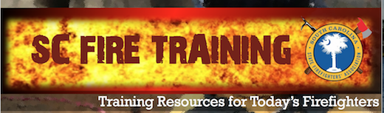
Announcing SC Fire Training on the web, Facebook, Twitter, and Instagram—Four great ways to share training resources and information!

SC Fire Training is a service to assist South Carolina firefighting and emergency response personnel with daily, weekly, and monthly resources to meet their continuing education training needs. The SC State Firefighters’ Association developed SC Fire Training with busy firefighters in mind, because they know career and volunteer fire service members face increasing demands on their time.
More than just a website, SC Fire Training incorporates social media and online learning systems to provide training information for emergency responders everywhere. SC Fire Training provides multiple convenient channels for firefighters to share training resources and other important information with each other. SCFireTraining.com provides a home base for South Carolina firefighter and emergency responder training and continuing education. SC Fire Training’s topic-based format means firefighters don’t have to endlessly search for specific training materials. Within each topic, you can easily find online courses, websites, presentations, nightly or shift-based drill ideas, videos, simulations, and other training materials. Bookmark SCFireTraining.com in your browser! Follow @SCFireTraining on Twitter and Instagram, and “Like” SC Fire Training on Facebook.

Training officers, company officers, instructors, and firefighters can submit links, documents, or other materials that may benefit others across our state and beyond. We need your input to help the SC Fire Training community grow! If you have ideas for drills or other types of training or would like to share materials you developed for your crew or department, we invite you to actively participate in the discussion. Submit materials to the SCFireTraining.com website, so others can benefit from them. Post information and photos to our social media channels about your training activities and successes. For those who have questions, the SC Fire Training communications outlets can help you find answers.

SC Fire Training—providing training resources for today’s firefighters.

